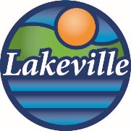

AGENDA

LAKEVILLE AREA ARTS CENTER Advisory Board

April 9, 2026 3:30 p.m.

Rehearsal Room 103 – Fine Arts Building

- Call to order
- Approval of January 8, 2026 minutes
- New Member Introductions
- Election of Officers

- Strategic Planning with Aurora Consulting
Al Onkka-Principal Consultant
With his practical, lighthearted, outcome-based approach, Al helps his clients imagine and realize a different future – big or small, short or long. Using focused questions, purposeful engagement, and transparent process, Al helps nonprofit teams collaborate to crystalize their vision and define practical steps to make progress together toward ambitious, yet achievable goals. He is inquisitive, analytical, good at connecting ideas, encouraging, and affable. Al is a Technology of Participation certified facilitator and a qualified administrator of the Intercultural Development Inventory (IDI). He uses inclusive and transparent facilitation and coaching best practices to engage groups in positive and productive work.

- YOY Dashboard
- FLAAC Update
- Announcements
- Adjourn

